**Texas Hold'em Poker**

**Team (40)**

**Members**

Eslam Emad Ahmed Rady.

Eslam Magdy Khair El-din.

* What is Texas Hold'em Poker?

Texas hold 'em (also known as Texas holdem, hold 'em, and holdem) is a variation of the card game of [Poker](https://en.wikipedia.org/wiki/Poker).

**Poker** is a family of [gambling](https://en.wikipedia.org/wiki/Gambling) [card games](https://en.wikipedia.org/wiki/Card_game), but is often considered a skill based game. All poker variants involve [betting](https://en.wikipedia.org/wiki/Betting_(poker)) as an intrinsic part of play, and determine the winner of each hand according to the combinations of players' cards, at least some of which remain hidden until the end of the hand. Poker games vary in the number of cards dealt, the number of shared or "community" cards, the number of cards that remain hidden, and the [betting procedures](https://en.wikipedia.org/wiki/Betting_in_poker).

* How does it work?

Two cards, known as the hole cards or hold cards, are dealt face down to each player, and then five [community cards](https://en.wikipedia.org/wiki/Community_card_poker) are dealt face up in three stages. The stages consist of a series of three cards ("the flop"), later an additional single card ("the turn" or "fourth street") and a final card ("the river" or "fifth street"). Each player seeks the best five card poker hand from the combination of the community cards and their own hole cards. If a player's best five card poker hand consists only of the five community cards and none of the player's hole cards, it is called "playing the board". Players have betting options to [check](https://en.wikipedia.org/wiki/Betting_in_poker#Check), call, raise or fold. Rounds of betting take place before the flop is dealt, and after each subsequent deal.

* What is an 'Out'?
* In a [poker](https://en.wikipedia.org/wiki/Poker) game with more than one betting round, an **out** is any unseen card that, if drawn, will improve a player's hand to one that is likely to win. Knowing the number of outs a player has is an important part of poker strategy. For example in [draw poker](https://en.wikipedia.org/wiki/Draw_poker), a hand with four diamonds has nine outs to make a flush: there are 13 diamonds in the deck, and four of them have been seen. If a player has two small pairs, and he believes that it will be necessary for him to make a [full house](https://en.wikipedia.org/wiki/Full_house_(poker)) to win, then he has four outs: the two remaining cards of each rank that he holds.
* One's number of outs is often used to describe a drawing hand: "I had a two-outer" meaning you had a hand that only two cards in the deck could improve to a winner, for example. In [draw poker](https://en.wikipedia.org/wiki/Draw_poker), one also hears the terms "12-way" or "16-way" straight draw for hands such as **6♥ 7♥ 8♠ (Joker)**, in which any of sixteen cards (4 fours, 4 fives, 4 nines, 4 tens) can fill a straight.
* The number of outs can be converted to the probability of making the hand on the next card by dividing the number of outs by the number of unseen cards. For example, say a [Texas Holdem](https://en.wikipedia.org/wiki/Texas_Holdem) player holds two spades, and two more appear in the flop. He has seen five cards (regardless of the number of players, as there are no upcards in Holdem except the board), of which four are spades. He thus has 9 outs for a flush out of 47 cards yet to be drawn, giving him a 9/47 chance to fill his flush on the turn. If he fails on the turn, he then has a 9/46 chance to fill on the river. Calculating the combined odds of filling on *either* the turn or river is more complicated: it is (1 - ((38/47) * (37/46))), or about 35%.
* Decision Making
* The AI implemented in our project establishes its' decision upon two main functions that fill 6 pieces of information.
  + First, the AI is able to recognize what hand it holds through getMyHand() ,which also identifies the effective factor in that hand.

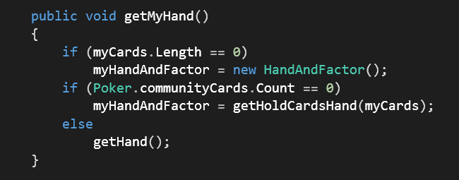

* Second, getMyDecision() which sets multiple probabilities based on the OUTS.
* It checks whether every hand couldExist or not, based on the hold cards and the current community cards, taking into account the player's current hand and starting from

the next better hand. (This is performed using a delegate)

* getMyDecision() fills four probabilistic containers that help the AI reach a decision regarding his bet.

1. PossibleHands.
2. Probability. (probability of every hand's occurrence in this round)
3. NeededCards. (Basically, the outs)
4. ProbabilityOfWinning. (The main decision making variable)

References

<https://en.wikipedia.org/wiki/Poker>

<https://en.wikipedia.org/wiki/Texas_hold_'em>

<https://en.wikipedia.org/wiki/Out_(poker)>